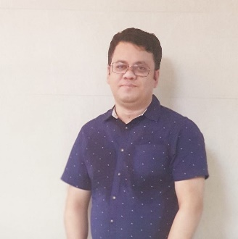**Biography of Shibly Noman**

Name: Shibly Noman

Occupation: Government Official

Shibly Noman is a dedicated and accomplished government official who has made significant contributions in various administrative roles throughout his career. Currently serving as the Executive Officer Senior Assistant Secretary at the Rangamati Zila Parishad, he has a proven track record of excellence in public service.

Shibly's journey in public service began with his tenure as the Former Upazila Nirbahi Officer in Chakaria, Cox's Bazar. In this role, he demonstrated exemplary leadership and an unwavering commitment to the welfare of the community. His efforts were instrumental in fostering development and addressing the needs of the people in the region.

Prior to his assignment in Chakaria, Shibly Noman served as the Former Assistant Commissioner Land in Ukhiya, Cox's Bazar. His experience in land management and administrative responsibilities helped shape his expertise in various aspects of governance.

Shibly's career also includes a role as the Former Assistant Commissioner in Gopalganj, where he continued to demonstrate a strong sense of duty and a commitment to serving the public interest.

Shibly Noman's academic journey has been equally impressive. He pursued a Master of Arts in Development Studies at the Institute of Development Studies, which equipped him with the knowledge and skills necessary to address complex development challenges. Additionally, he completed a Master of Science in Applied Economics from BRAC University, further enhancing his analytical abilities and understanding of economic principles.

Shibly's educational foundation is rooted in the University of Chittagong, where he studied English Literature & Language. This diverse educational background has undoubtedly contributed to his ability to communicate effectively and approach problem-solving with a holistic perspective.

While Shibly Noman's professional life is focused on public service, he is proud to call Rangamati his home, and his roots trace back to Chunati in Chittagong, Bangladesh. His passion for serving the people and making a positive impact on society continues to drive his career and dedication to the betterment of his community and the nation as a whole.

Shibly Noman's exemplary service in various government roles and his commitment to self-improvement through education make him a distinguished figure in the field of public administration in Bangladesh. His work and dedication have positively impacted the lives of many, and he remains a valuable asset to the nation.